Formatting text

Using the Format Toolbar
One way to format the content of a cell is to use the format toolbar. Font and cell attributes can be added from shortcut buttons on the formatting bar. If this toolbar is not already visible on the screen, select View Menu|Toolbars|Formatting from the menu bar.
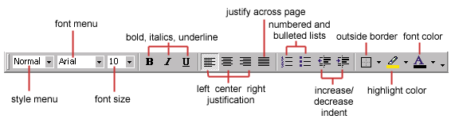

Using the Format Dialog box
For a complete list of formatting options, right-click on the highlighted cells and choose Format Cells from the shortcut menu or select Format|Cells from the menu bar.
The following dialogue boxes show the different features you can set.
1 Number — The data type can be selected from the options on this tab. Select General if the cell contains text and number, or another numerical category if the cell is a number that will be included in functions or formulas.
The Format Cells dialogue box is shown below with the Number tab selected:
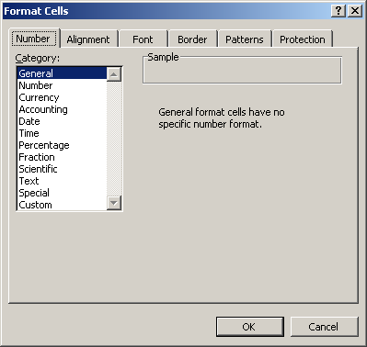

2 Alignment — These options allow you to change the position and alignment of the data with the cell.
The Format Cells dialog box is shown below with the Alignment tab selected:
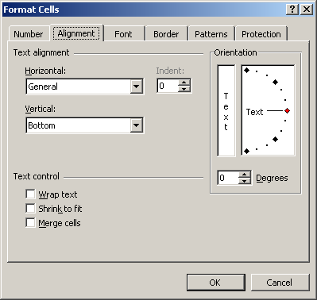

3 Font —All font attributes are displayed in this tab including font face, size, style, and effects.
Shown below is the Format Cells dialog box with the Font tab selected:
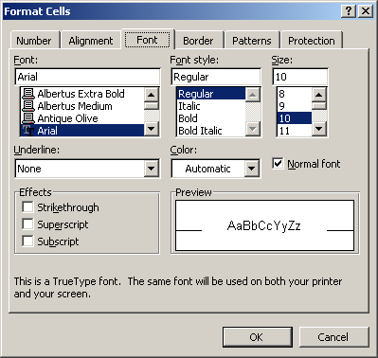

4 Border and Pattern —These tabs allow you to add borders, shading, and background colours to a cell.
Shown below is the Format Cells dialogue box with the Border tab selected:
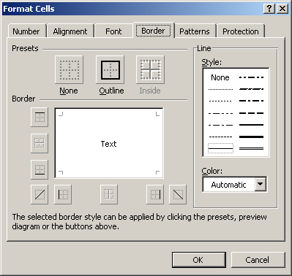
Shown below is the Format Cells box with the Patterns tab selected:
